2024 Applied Mathematics Ordinary Level

Question 1
A car is travelling on a straight level road.
The car is travelling with a speed of 25 m s^{–1} when it passes a shop.
After passing the shop it immediately decelerates uniformly for 5 seconds to a speed of 10 m s^{–1}.
The car continues at this speed for 5 seconds. It then accelerates uniformly from 10 m s^{–1} to a speed of 20 m s^{–1}, in 60 m.
- Calculate the deceleration of the car.
- Calculate the acceleration of the car.
- Calculate the time the car spends accelerating, from 10 m s^{–1} to a speed of 20 m s^{–1}.

- Once the car reaches 20 m s^{–1} it continues to travel at this speed.
After 10 s, it passes a parked speed van.
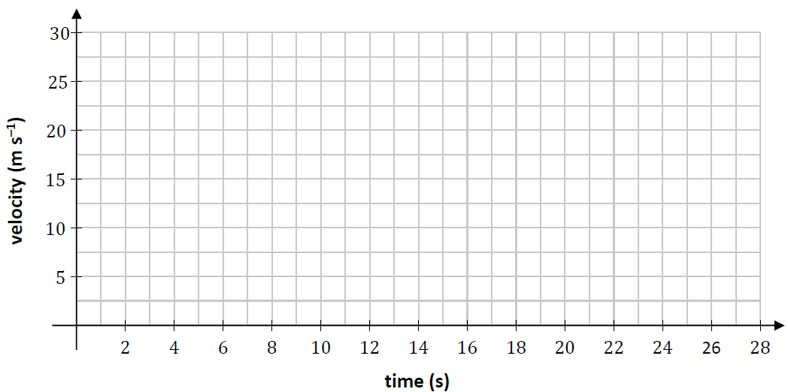
Using the axes below, draw an accurate velocity-time graph showing the motion of the car from the shop to the speed van.
- There is a speed limit of 80 km per hour on this road.
Investigate if the car is within the speed limit as it passes the speed van.
- Calculate the average speed of the car between the shop and the speed van.

Question 2
Two tugboats, 𝑃 and 𝑄, pull a ship.

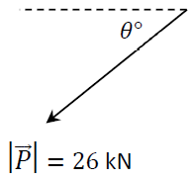
The pulling force 𝑃⃗, has a magnitude of 26 kN and a direction 𝜃 south of west, where $\tan{θ=\frac{12}{5}}$.

The pulling force 𝑄⃗ = −10$\vec{i}$ − 6$\vec{j}$ kN.

- Express $\vec{P}$ in terms of the unit vectors $\vec{i}$ and $\vec{j}$.
- Calculate $\vec{P}$ ⋅ $\vec{Q}$, the dot product of $\vec{P}$ and $\vec{Q}$.
- Calculate the angle between $\vec{P}$ and $\vec{Q}$.
- Calculate $\vec{P}$ + $\vec{Q}$.
- Explain what the vector $\vec{P}$ + $\vec{Q}$ represents in this context.
- Calculate $\left|\vec{P}+\vec{Q}\right|$.

- To find the displacement 𝑠 of the ship, with initial velocity 𝑢 and acceleration 𝑎, at any time 𝑡, in the $\vec{i}$ or $\vec{j}$ direction, we use the equation: $s=ut+\frac{1}{2}at^{2}$.
Use dimensional analysis (comparison of units) to show the units on either side of the equation are equivalent.

Question 3 (a)
Olivia wishes to build her running mileage gradually to avoid overuse injuries.
She decides to increase her running time each week by 10%.
At the start of her training (𝑛 = 0), her running time is 15 minutes.
Some of the running times are shown in the table below, where her running time in her first week is shown under 𝑛 = 1.

n (weeks) | n = 0 | n = 1 | n = 2 | n = 3
Rn (minutes) | 15 | 16.5 | 18.15

- Complete the table, by calculating 𝑅₃, 𝑅₄ and 𝑅₅, her running times in week 3, 4 and 5 respectively. Write each answer correct to 2 decimal places.

- The time she will run each week can be modelled by the difference equation:

$$R_{n+1}={1.1R}_{n}$$
where 𝑛 ≥ 0, 𝑛 ∈ ℤ, R₀ = 15.
Solve the difference equation to find an expression for 𝑅_{n} in terms of 𝑛.

- Olivia estimates that she will have run 3.5 hours in total, over the first eight weeks of training, beginning at 𝑛 = 1. Calculate the sum of her running times in these eight weeks and evaluate to see if she is correct.
- In what week will Olivia have run 4 hours in total?

Question 3 (b)
Aoife is an Applied Mathematics student.
While at a funfair she observes her little brother, Daniel, on the merry-go-round.
Daniel, of mass 25 kg, is sitting on one of the horses that is 2 m from the centre.
He is moving at a speed of 1 m s^{–1}.
Daniel moves with uniform circular motion.
- Calculate Daniel’s angular velocity, 𝜔.

- Aoife notices that some of the other horses are closer to the centre and some are further away than where Daniel sits.
Aoife believes that if Daniel had been sitting on the horse that is 1 m from the centre, he would be moving with a greater linear velocity. Is she correct? Justify your answer.
- Calculate Daniel’s acceleration.
- Calculate the centripetal force on Daniel.
- If Daniel completes 20 revolutions on the merry-go-round, calculate how long it will take.

Question 4
A basketball player is practising free throws, which are taken 4.7 m in front of a vertical hoop.
The player throws the ball with an initial velocity of $5\vec{i}+5\vec{j}$ m s^{–1}, as shown in the diagram below.

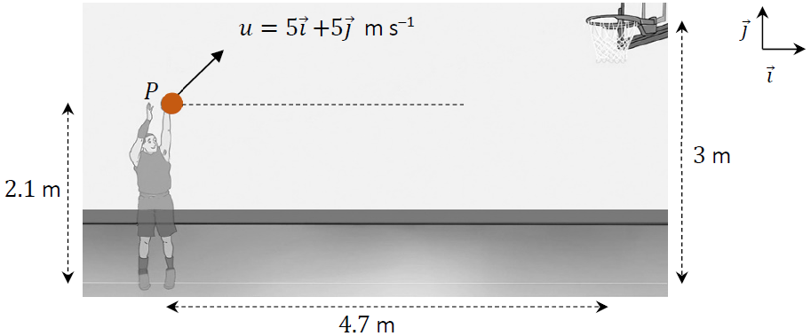

The motion of the basketball may be modelled as projectile motion in a vertical plane, ignoring the effects of air resistance.
The player releases the basketball, from 𝑃, at a height of 2.1 m above the ground and the basketball hoop stands at 3 m.
- Calculate the time taken for the basketball to reach its maximum height above the ground.
- Show that the maximum height of the basketball above the ground is approximately 3.38 m.
- Calculate the two times, 𝑡₁ and 𝑡₂, when the ball is at the same height as the hoop.
- Calculate the basketball’s horizontal displacement from 𝑃, at 𝑡₂, the second time the ball is at the same height as the hoop.
- Hence, explain why the basketball will not enter the hoop, at 𝑡2.
- After several more attempts, the basketball player starts to score the free throws consistently.
Suggest one change the basketball player could have made to the throw, to achieve this.

Question 5 (a)
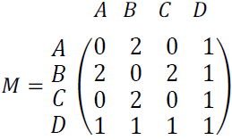
The adjacency matrix 𝑀 is given as

- Draw a suitable graph to represent the adjacency matrix 𝑀.

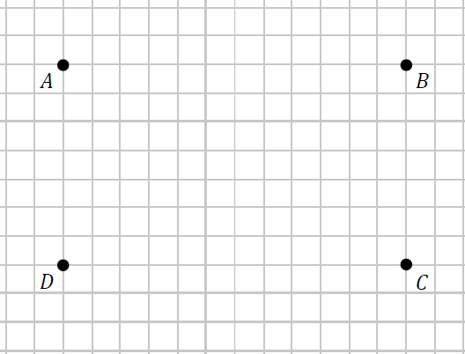

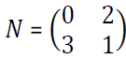
- Another adjacency matrix 𝑁 is given as

Calculate 𝑁² and explain what the entries in the matrix 𝑁² represent.

Question 5 (b)
Andrew is planning a three-week campervan trip around Connemara. He is looking to visit popular areas that have appropriate parking for his campervan.
He will collect the campervan at location 𝐴 at the start of week one and return it to location
𝐻 at the end of week three.
He has the option of basing himself in location 𝐵, 𝐶 or 𝐷 for week one. For week two his options are 𝐸, 𝐹 or 𝐺. He will then need to return the campervan at location 𝐻 at the end of week three.

Andrew draws the network shown below to help him design the best route.
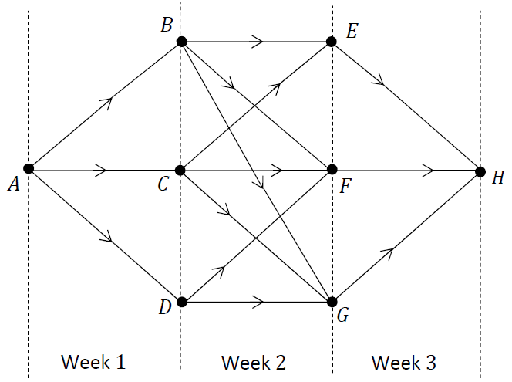

The table below gives the distances in km between each of the locations.
Journey | Distance in km |  | Journey | Distance in km
A to B | 13 |  | C to F | 16
A to C | 12 |  | C to G | 13
A to D | 14 |  | D to F | 14
B to E | 16 |  | D to G | 13
B to F | 14 |  | E to H | 13
B to G | 11 |  | F to H | 16
C to E | 18 |  | G to H | 15

Use Bellman’s Principle of Optimality to calculate the path from location 𝐴 to 𝐻 which minimises the distance Andrew needs to drive in the campervan.
Relevant supporting work must be shown.

Question 6 (a)

Andrea wants to mathematically model the optimal route for a road trip, which involves visiting the five cities shown on the map.
Andrea conducts research on Google Maps on a Sunday morning at 8 a.m.
According to Google Maps, the estimated time, in minutes, needed to travel between any two of these cities is shown in the following table.

Time (s) | Cork | Dublin | Galway | Limerick | Waterford
Cork | - | 162 | 147 | 82 | 105
Dublin | 162 | - | 138 | 127 | 114
Galway | 147 | 138 | - | 75 | 182
Limerick | 82 | 127 | 75 | - | 118
Waterford | 105 | 114 | 182 | 118 | -

- Draw a network to represent this information.
On your network the weights of the edges should represent the times to travel between the cities, which should be represented by labelled nodes.

- Andrea wants to minimise the amount of time travelling between the cities.
Using an appropriate algorithm, find the minimum spanning tree for this network.
Name the algorithm you used. Relevant supporting work must be shown.

- Explain a limitation to Andrea’s model.

Question 6 (b)
On her road trip Andrea comes across an unexpected road closure.
In the network shown below, the edges represent roads and the nodes represent junctions of two or more roads, labelled 𝐴 to 𝐻.
Node 𝐴 represents the junction where the road closure begins.
The remaining roads available to travel on are represented by edges and node 𝐻 represents the end of the road closure.
Once Andrea reaches node 𝐻, she is back on her original route.
The time, in minutes, to travel between each junction is shown in the network below.
Andrea wants to take the shortest route, to minimise the disruption to her plan.

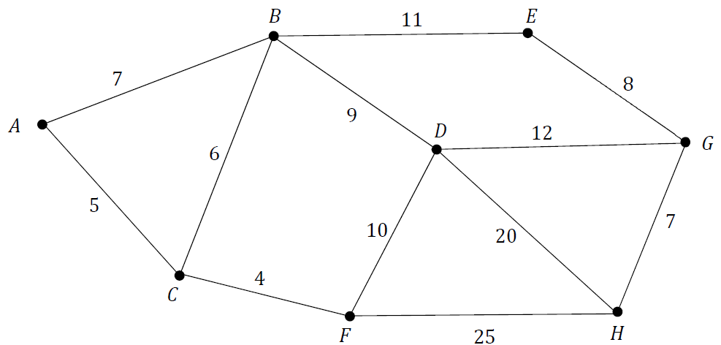

Use Dijkstra’s algorithm to find the shortest path from junction 𝐴 to junction 𝐻 and calculate the shortest time. Relevant supporting work must be shown.

Question 7
A small smooth sphere, 𝐴, of mass 4 kg travels with a constant speed of 5 m s^{–1}.
It collides with another small smooth sphere, 𝐵, of mass 6 kg travelling in the same direction with a speed of 2.5 m s^{–1}.
The coefficient of restitution between the spheres is 𝑒.
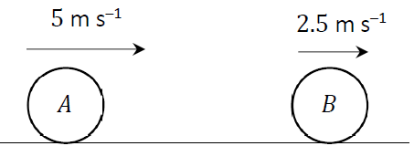

After impact, sphere 𝐵 continues to travel in the same direction, but with a speed of 4 m s^{–1}.
- Calculate the speed of 𝐴 after impact.
- Calculate the value of 𝑒.
- Calculate the total kinetic energy of the system before impact.
- Calculate the percentage loss in kinetic energy as a result of the impact.
- Calculate the impulse imparted on each sphere as a result of the impact.
- Explain the relationship between the impulse imparted on each sphere.

Question 8 (a)
Rugby players are trying to push a 500 kg scrum machine along rough horizontal ground.
The force exerted by the rugby players is horizontal.
The coefficient of friction between the scrum machine and the ground is 0.65.
- Draw a diagram to show the forces acting on the scrum machine.
- Calculate the vertical normal reaction force on the scrum machine.
- If the players exert a horizontal force of 3000 N on the scrum machine, will the scrum machine move?
Give a reason for your answer.

Question 8 (b)
An Applied Mathematics class set up an experiment to model the motion of connected particles.
They connected a particle of mass 1 kg to another particle of mass 0.6 kg, by a taut light inelastic string, as shown in the diagram below.
The string passed over a smooth light pulley at the edge of a rough horizontal table.
The coefficient of friction between the 1 kg mass and the table was assumed to be 0.5.
The system was released from rest.
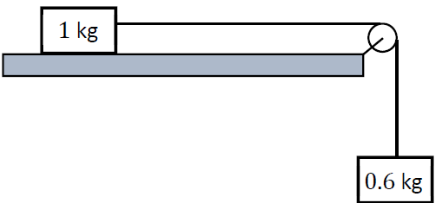
- Draw separate diagrams to show the forces acting on the masses when they are moving.
- Calculate the common acceleration of the masses.
- Calculate the tension in the string.

Question 9
The diagram below shows the scheduling network for a stage set up for a concert.
The network provides some information about the relationship between the twelve activities that have to be completed as part of completing the stage set up.
The edges of the network represent these activities and are labelled with the letters 𝐴 to 𝐿.
The duration, in hours, of each activity is represented by the number in brackets. The letters used to label the edges should not be taken as representing the order in which the activities happen.
The nodes of the network represent events or points in time during the set up.
The source node is the time when the project begins and the sink node is the time when the project ends.

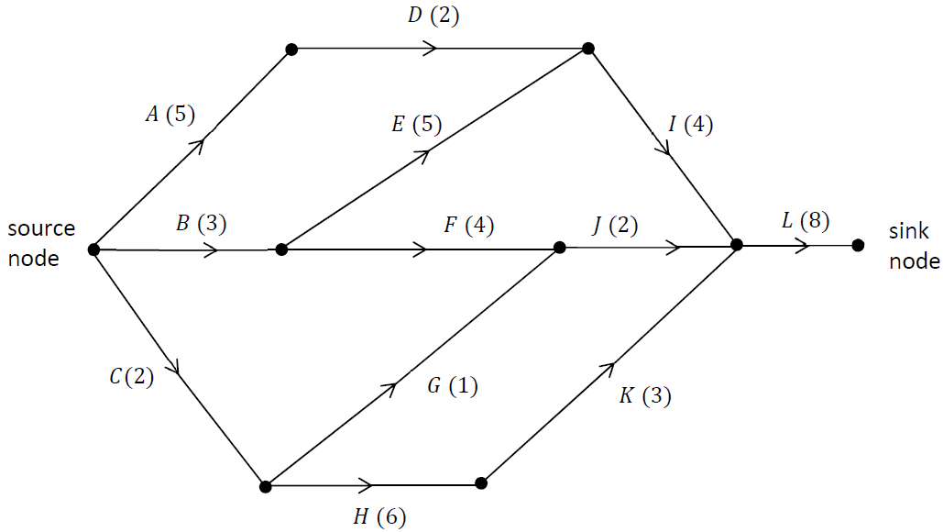

- Complete the table by listing, for each activity, the other activities on which it depends directly. That is, for each activity 𝑋 ∈ $\left\{D, E, … , L\right\}$, write the smallest possible list of other activities that need to be completed before activity 𝑋 can begin.

Activities 𝐴, 𝐵 and 𝐶 do not depend on any prior activities, so the list is empty for these activities, as shown.

Activity | Depends directly on . . |  | Activity | Depends directly on …
A | - |  | G
B | - |  | H
C | - |  | I
D |  |  | J
E |  |  | K
F |  |  | L

- Calculate the early time and the late time for each event.
Complete the diagram below by writing the early time (upper box) and late time (lower box) at the node representing each event.

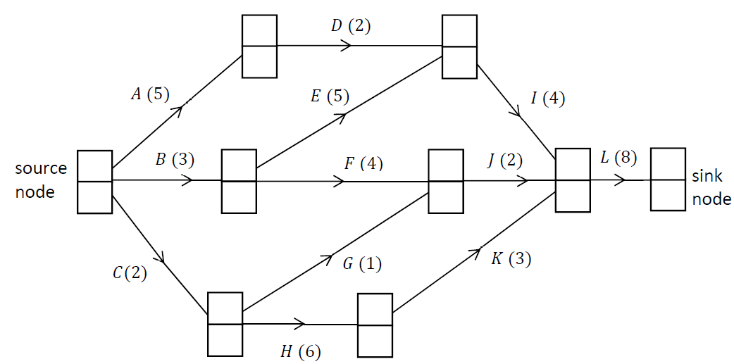

- Write down the critical path for the network.

- Write down the minimum time, in hours, needed to complete the stage set up.

- Due to an issue with lighting, activity 𝐺 is delayed by four hours.
Does this cause a delay in finishing the stage set up? Justify your answer.

- The stage crew complete a ten-hour shift on their first day of setting up the stage.
State which activities must be happening when they start again on day two.

Question 10 (a)
A small local jewellery business started selling their products online on January 1st 2024.
They sold nine pieces of jewellery in January and twelve pieces in February.
With a marketing plan the business predicts a strong growth in online sales.
They predict that 𝐽, the number of such jewellery pieces sold in any month, will be equal to the number of pieces sold the previous month plus twice the number of pieces sold the month before that.
This prediction can be expressed as the second-order difference equation:

$$J_{n+2}-J_{n+1}-{2J}_{n}=0$$

where 𝑛 ≥ 0, 𝑛 ∈ ℤ, 𝐽₀ = 9 and 𝐽₁ = 12.

This difference equation has the characteristic quadratic equation 𝑥² − 𝑥 −2 = 0.

- Solve this quadratic equation, i.e. calculate the two roots of the equation.
- Hence or otherwise, solve the difference equation to find an expression for 𝐽_{n} in terms of 𝑛.
- Calculate the number of pieces of jewellery that the model predicts the business will sell in July (month 6 of trading online).

Question 10 (b)
John’s parents started a college fund for him when he was born in June 2006.
On his birth date they invested €3000.
Every year after that, on his birthday, they put €1500 into the fund, which earned a fixed annual interest rate of 5.5%.
The value, 𝑃, in €, of John’s college fund after 𝑛 years may be modelled by the difference equation:

$$P_{n+1}={1.055P}_{n}+1500$$

where 𝑛 ≥ 0, 𝑛 ∈ ℤ and 𝑃₀ = 3000.

- Solve this difference equation to find an expression for 𝑃_{n}, the value of John’s college fund after 𝑛 years.
- Calculate 𝑃₁₈, the value of John’s college fund on his eighteenth birthday.

- Rather than use the entire fund his parents accumulated for college, John decided to work part time and invest €25 000 into his own new fund.
John found a slightly better fixed annual rate of 5.7%.
He decided to invest €200 on his birthday each year while in college.
Write down the difference equation that models the value, in €, of John’s investment fund after 𝑛 years.

